Introduction
Significant progress has been made in the field of quantum information science over the past ten years, on the theoretical fronts of algorithms, fault-tolerance and system architectures, as well as the experimental efforts towards realizing a scalable quantum hardware. The promise of utilizing quantum resources for useful information processing tasks is approaching a practical reality.
This two-day conference seeks to invite the leading researchers around the world pushing the frontiers of quantum information science, to share the excitement and challenges that the community faces ahead. The topics that will be discussed include cutting-edge theoretical progress in quantum information processing, and state-of-the-art experimental results in various physical platforms such as atomic, solid state, and photonic systems.

List of Invited Speakers
Jaewook Ahn (KAIST) | Rainer Blatt (U. Innsbruck)
Yonuk Chong (KRISS) | Jerry Chow (IBM)
Akira Furusawa (U. Tokyo) | Hartmut Haeffner (UC Berkeley)
Winnie Hensinger (U. Sussex) | Hyunseok Jeong (SNU)
Dohun Kim (SNU) | Kihwan Kim (Tsinghua U.)
Na Young Kim (U. Waterloo) | Taehyun Kim (SK telecom)
Dmitry Matsukevich (NU. Singapore) | Misha Lukin (Harvard U.)
Sae Woo Nam (NIST) | Christopher Monroe (U. Maryland)
Hanhee Paik (IBM) | William Oliver (MIT-Lincoln Lab.)
Gerhard Rempe (Max Planck Institute) | Hee Su Park (KRISS)
Zhen-Sheng Yuan (USTC) | Sven Rogge (U. of New South Wales)
Hannes Bernien (Harvard U.) | Peter Zoller (U. Innsbruck)

Organizers
Jungsang Kim (Duke U.) | Jaewan Kim (KIAS)
Yonuk Chong (KRISS) | Kihwan Kim (Tsinghua U.)
Kyung Soo Choi (U. Waterloo) | Hanhee Paik (IBM)
Seung-Woo Lee (KIAS) – Conference Secretary

Contact Miriam Hyeon (KIAS) – kiasquc@kias.re.kr
Shuttle Bus Hours
DATE | TIME | DEPARTURE | ARRIVAL
July 22 (Fri) | 08:20 a.m | Holiday Inn | KIAS
 | 18:20 p.m | KIAS | Holiday Inn
July 23 (Sat) | 08:20 a.m | Holiday Inn | KIAS
 | 18:50 p.m | KIAS | Holiday Inn
July 24 (Sun) | 12:30 p.m | Holiday Inn | ICAP Venue
Program Schedule Day 1 – July 22 (Fri)
08:30-09:00 | Registration/Coffee & Sandwiches
09:00-10:30 | Plenary I: Modular and Reconfigurable Quantum Computing with Trapped Ions | Christopher Monroe  (U. Maryland)
 | Plenary II: Quantum error detection, high-fidelity control, and experiencing other things quantum | Jerry Chow (IBM)
10:30-11:00 | BREAK
11:00-12:30 | Plenary III: Quantum Information Science with Trapped Ca+ Ions | Rainer Blatt (U. Innsbruck)
 | Plenary IV: Australia’s Quantum Perspective | Sven Rogge  (U. New South Wales)
12:30-14:00 | LUNCH
14:00-16:00 | Nano-Scale `Dark State'  Optical Potentials for Cold Atoms | Peter Zoller (U. Innsbruck)
 | High fidelity qubit operations  in trapped ion quantum computation | Jungsang Kim (Duke U)
 | Towards a new class of trapped  ion experiments with ion rings | Hartmut Haeffner (UC Berkeley)
 | High NOON State of Phonons  in a Trapped Ion System | Kihwan Kim (Tsinghua U.)
16:00-16:30 | BREAK
16:30-18:00 | A quantum parametric oscillator with trapped ions | Dzmitry Matsukevich (NUS)
 | Constructing a trapped-ion quantum computer | Winfried Hensinger (U. Sussex)
 | Development of quantum information technologies at SK telecom | Taehyun Kim (SK telecom)
* A banquet will be held in Holiday Inn from 18:20pm. Please refer to the shuttle information above.
There is a 10,000 KRW fee to participate in the banquet.
Day 2 –July 23 (Sat)
08:30-09:00 | Coffee & Sandwiches
09:00-10:30 | Cavity Quantum Electrodynamics: A Toolbox for Scalable Quantum Information Science | Gerhard Rempe (MPI)
 | Observation of Four-body Ring-exchange Interactions and Anyonic Fractional Statistics in Optical Lattices | Zhen-Sheng Yuan (USTC)
 | Moving microtraps for low-entropy  arrays of atomic qubits | Jaewook Ahn (KAIST)
10:30-11:00 | BREAK
11:00-12:30 | Engineering a Better Superconducting Flux Qubit | William Oliver (MIT)
 | Current status of the superconducting qubit technology in KRISS | Yonuk Chong (KIRSS)
 | Quantum gates for superconducting qubits | Hanhee Paik (IBM)
12:30-14:00 | LUNCH
14:00-16:00 | Hybrid Quantum Information Processing | Akira Furusawa (U. Tokyo)
 | Quantum information processing with light beyond single photon qubits | Hyunseok Jeong (SNU)
 | Loophole-free Bell tests  for a Random Number Beacon | Sae Woo Nam (NIST)
 | Transmission of Photonic Spatial Qudits through Optical Fibers | Hee Su Park (KRISS)
16:00-16:30 | BREAK
16:30-18:30 | Exciton-Polariton Quantum Information Processing | Na Young Kim (U. Waterloo)
 | Semiconductor quantum dot based  quantum electronics | Dohun Kim (SNU)
 | Quantum science with atom-like  defects in diamond | Misha Lukin (Harvard U.)
 | Cold Matter Assembled Atom-by-Atom | Hannes Bernien (Harvard U.)
18:30- | Closing

[Plenary I] Modular and Reconfigurable Quantum Computing with Trapped Ions

Christopher Monroe, JQI and University of Maryland

Electromagnetically trapped atomic ions are qubit standards, with unsurpassed levels of quantum coherence and near-perfect measurement. When qubit state-dependent laser or microwave forces are applied to ions in a crystal, their Coulomb interaction is modulated in a way that forms entangling quantum gates or global quantum magnetic interactions. Recent experiments have implemented tunable and reconfigurable long-range interacting spin models with up to 25 qubits. Scaling to even larger numbers can be accomplished by coupling the qubits to optical photons, where entanglement can be formed over remote distances for applications in quantum communication and distributed quantum computing. The engineering of this modular and reconfigurable quantum architecture will likely accompany the development of applications that match the connectivity of the system, in what could be termed "quantum co-design."

[Plenary II] Quantum error detection, high-fidelity control, and experiencing other things quantum

Jerry Chow, IBM

Fault tolerant quantum computing is possible by employing quantum error correction techniques. In this talk I will describe an implementation of various small quantum codes using lithographically defined superconducting qubits in latticed arrangements. These codes explore a new area of quantum information processing, including the detection of full quantum errors and the encoding of a logical qubit. Our experiments require highly coherent qubits, high quality quantum operations implementing the detecting circuit, and high quality independent qubit measurements. Looking beyond further, there remains both theoretical and experimental control hurdles which must be overcome to build verifiably reliable quantum networks of qubits. I will present some experiments which point towards these important questions and give proposals for future integration capability, measurement integration, and scalable control architectures. The focus will be on a variety of questions which will increasingly become important as the field moves towards a larger network of qubits.

[Plenary III] Quantum Information Science with Trapped Ca+ Ions

Rainer Blatt, Institute for Experimental Physics, University of Innsbruck, and
Institute for Quantum Optics and Quantum Information, Austrian Academy of Sciences

In this talk, the basic toolbox of the Innsbruck quantum information processor based on a string of trapped Ca+ ions will be reviewed. For quantum information science, the toolbox operations are used to encode one logical qubit in entangled states distributed over seven trapped-ion qubits. We demonstrate the capability of the code to detect one bit flip, phase flip or a combined error of both, regardless on which of the qubits they occur. Furthermore, we apply combinations of the entire set of logical single-qubit Clifford gates on the encoded qubit to explore its computational capabilities. The quantum toolbox is further applied to carry out both analog and digital quantum simulations. The basic simulation procedure will be presented and its application will be discussed for a variety of spin Hamiltonians. As a particular example we report on an investigation of quantum dynamics in long spin chains, which can be described by particle-like carriers of information that emerge in the collective behavior of the underlying system, the so-called quasiparticles. A spectroscopic technique is presented to study artificial quantum matter and to use it for characterizing quasiparticles in a many-body system of trapped atomic ions. An overview of the status and goals of the Innsbruck experiments on quantum information science with trapped Ca+ ions will be given.

[Plenary IV] Australia’s Quantum Perspective

Sven Rogge, Centre for Quantum Computation and Communication Technology,
University of New South Wales

Silicon offers a particularly interesting platform for spin qubits because when isotopically purified, silicon acts as a “semiconductor vacuum” for spins, giving it extraordinary coherence. The exceptionally long quantum coherence times of phosphorus donor nuclear spin qubits in silicon [1], coupled with the proven scalability of silicon-based nano-electronics, make them attractive candidates for large-scale quantum computing. This talk will address key ingredients such as the readout of single-atom qubits [2] including optical access [3] and coherent spin manipulation that forms a single-qubit gate [1]. Furthermore, atomic-scale device fabrication based on hydrogen desorption lithography [4] will be presented in context of a scaleable fault tolerant surface code architecture [5]. To optimise gates for this architecture quantum-state imaging allows the determination of the exact position of phosphorus donors in the Si matrix. This technique has the ability to image coupled qubits and measure their coupling strength that can be compared to atomistic theory [6, 7]. Finally, a first step towards analog quantum computation in Si is demonstrated with the experimental implementation of a two site Hubbard problem based on impurities [8]. All this is placed in context of the Australian effort to develop a Si based quantum processor.
1. Muhonen, Storing quantum information for 30 seconds in a nanoelectronic device. Nature Nanotech 9(12):986-991 (2014)
2. Morello, Single-shot readout of an electron spin in silicon. Nature 467 (7316):687-691 (2010)
3. Yin, Optical addressing of an individual erbium ion in silicon. Nature 497 (7447): 91 (2013)
4. Fuechsle, A single-atom transistor, Nature Nanotechnology 7:242–246 (2012)
5. Hill, A surface code quantum computer in silicon. Science Advances 1(9):e1500707 (2015)
6. Salfi, Spatially resolving valley quantum interference of a donor in silicon. Nature Materials 13:605 (2014)
7. Usman, Spatial metrology of dopants in silicon with exact lattice site precision. Nature Nanotechnology (2016) doi:10.1038/nnano.2016.83
8. Salfi, Quantum simulation of the Hubbard model with dopant atoms in silicon. Nature Communications 7:11342 (2016)

[Talk 1] Nano-Scale `Dark State' Optical Potentials for Cold Atoms

M. Łącki, H. Pichler, M. Baranov and P. Zoller
Institute for Theoretical Physics, University of Innsbruck,
and Institute for Quantum Optics and Quantum Information, Austrian Academy of Sciences

The optical potentials for cold atoms we know, such as optical traps or optical lattices, are based on second-order AC Stark shifts of an electronic atomic level, which is proportional to the light intensity varying in space. For light in the far field, i.e. for optical trapping far away from surfaces, this spatial resolution will thus be given essentially by the wavelength of the light. In the quest to realize free-space optical subwavelength structures for atoms we will describe and study a family of conservative optical potentials, which arise as non-adiabatic corrections to dark states in atomic Lambda-type configurations, building on a strong non-linear atomic response to the driving lasers. This scheme allows the realization of optical barriers for atoms on the scale of tens of nanometers, and in combination with traditional optical potentials and lattices the formation of a complex `nano-scale' optical landscape for atoms. The present scheme should be of particular interest in the realizing many-atom quantum dynamics on the nano-scale as strongly interacting many-body systems.

The central idea is to write a periodic spatial spin-pattern on the atomic wavefunction with sub-wavelength resolution for atomic Lambda-systems. Our ‘dark state’ barriers and optical lattice arises from non-adiabatic corrections to this atomic motion, and we can readily add features to these optical nanoscale barriers including a spatially structured spin-orbit couplings. We present a detailed study of decoherence of the ‘dark state’ optical potentials due to coupling to the bright states, including effects of non-adiabaticity due to motion and spontaneous emission, and we show that these effects can be made negligible. Finally, we present examples like nano-structured atomic wires, and we give examples of many-body physics in such optical nano-scale structures.

[Talk 2] High fidelity qubit operations in trapped ion quantum computation

Jungsang Kim, Duke University

The ability to carry out high fidelity qubit manipulation in quantum computation is important for constructing fault-tolerant quantum computers. The fidelity of qubit manipulation in trapped ions have historically been limited by the ability to tailor the electromagnetic fields, in either the microwave or the optical frequencies, that provide the gate operations. We describe the advances in the performance enhancements for qubit state preparation, detection, and single qubit gate operations in a trapped ion qubit, utilizing advanced gate characterization protocols.

[Talk 3] Towards a new class of trapped ion experiments with ion rings

Hao-Kun Li, Erik Urban, Crystal Noel, Alexander Chuang, Yang Xia, Anthony Ransford, Boerge Hemmerling, Yuan Wang, Tongcang Li, Hartmut Haffner, Xiang Zhang
University of California, Lawrence Berkeley National Laboratory

We present the design and implementation of a novel surface ion trap allowing for trapping of ions in a ring configuration. A ring topology introduces a number of new features that are not present in conventional, linear ion traps, such as extremely low trap frequencies, periodic boundary conditions, translational symmetry and the ability to rotate. These new features open the possibility to conduct a new class of experiments previously inaccessible to ion traps. Towards this goal, we trap up to 20 ions 400 μm above the plane of a trap surface in a ring geometry with a diameter of 90 μm. The large trapping height relative to the ion-ion spacing gives us the the ability to control electric fields at the trapping point with only a few compensation electrodes. This control allows us to pin the ions either into a localized crystal on one side of the ring potential or to fully delocalize them over the full extent of the ring, demonstrating any symmetry breaking in our ring is on energy scales below the temperature of the laser cooled ions. We present studies of the trap frequencies in a pinned configuration and its transition to a depinned, rotating state.

[Talk 4] High NOON State of Phonons in a Trapped Ion System

Kihwan Kim, Tsinghua University

Multi-party entangled state, in particular, NOON state has brought great interests because it allows the precision measurement to the ultimate limit as the number of particles increases. However, experimental preparation of the NOON state with su ciently high N remains as a challenge. Here we develop a deterministic method to generate the NOON state of arbitrary phonon numbers and experimentally create the states up to N = 9 phonons in two radial modes of a single trapped 171Yb+ ion. We clearly observe the delity of the NOON state over classical limit by measuring the contrast of the characteristic phase oscillations and the populations through the phonon projective measurement of two motional modes. We also observe the Heisenberg scaling of phase sensitivity in the NOON states through quantum Fisher information. Our scheme is generic and directly applicable to cavity QED or circuit QED systems and optomechanical systems.

[Talk 5] A quantum parametric oscillator with trapped ions

Dzmitry Matsukevich, National University of Singapore

A parametric oscillator is a fundamental model in many branches of physics, including quantum optics, electronics and condensed matter physics. We report simulation of both degenerate and non-degenerate parametric oscillators using normal modes of motion of in the system of trapped ytterbium ions. The nonlinear coupling between the modes is induced by the anharmonicity of the Coulomb interaction between the ions and manifests itself on the level of single quanta. We experimentally explore several applications of these effects including simulation of the non-degenerate parametric down conversion in a regime of depleted pump, simulation of Jaynes-Cummings model, and measurements of the parity and Wigner functions of ions motional states.

[Talk 6] Constructing a trapped-ion quantum computer

Winfried K. Hensinger, University of Sussex

Trapped ions are a promising tool for building a large-scale quantum computer. I will report progress on the work of UK Quantum Technology Hub on Networked Quantum Technologies. In more detail will discuss work towards constructing two demonstrator devices, the 20:20 engine to be constructed at Oxford and the microwave trapped-ion quantum engine to be constructed at Sussex. A multiplicity of tasks is required for this purpose and I will report recent progress.

I will also describe a new approach for quantum computing with trapped ions. The number of required radiation fields (such as lasers) for the realisation of quantum gates in any proposed ion-based architecture scales with the number of ions inside the quantum computer, posing a major challenge when imagining a device with millions of qubits. Here I present a fundamentally different approach, where this scaling entirely vanishes. The method is based on individually controlled voltages applied to each logic gate location to facilitate the actual gate operation analogous to a traditional transistor architecture within a classical computer processor. Instead of aligning numerous pairs of Raman laser beams into designated entanglement zones, the use of a single microwave source outside the vacuum system is sufficient. We have demonstrated the key principle of this approach by implementing a two-qubit quantum gate based on long-wavelength radiation where we generate a maximally entangled two-qubit state with fidelity 0.985(12) .

[Talk 7] Development of quantum information technologies at SK telecom

Taehyun Kim, SK Telecom

At SK telecom, various technologies based on quantum information are currently being developed. The quantum key distribution (QKD) system developed by SK telecom is recently deployed in one segment of the commercial network in South Korea this year, and the current status of this test will be overviewed. Small and low-cost quantum random number generator (QRNG) chip is also under development and our plan for the QRNG chip will be discussed. Finally, I will present our development effort for the quantum repeater using ion trap, including the fabrication of ion trap chip, frequency conversion for long distance transmission, and our recent experiment based on sympathetic cooling of isotopic ions.

[Talk 8] Cavity Quantum Electrodynamics: A Toolbox for Scalable Quantum Information Science

Gerhard Rempe, Max Planck Institute of Quantum Optics

Optical cavities provide unparalleled capabilities in controlling the interaction of light and matter, and thus open up novel avenues for genuine quantum-mechanical applications like long-distance quantum networking and distributed quantum computation. With this backdrop, the talk will highlight the latest achievements, all based on the technique of detecting an optical photon nondestructively [1]. Highlights include the heralded inter-conversion of flying photonic and stationary atomic qubits [2] and the realization of long-standing dreams like quantum gates between a photonic polarization qubit and an atomic spin qubit [3] as well as between two photonic polarization qubits [4].

[1] A. Reiserer et al., Science 342, 1349 (2013).
[2] N. Kalb et al., PRL 114, 220501 (2015).
[3] A. Reiserer et al., Nature 508, 237 (2014).
[4] B. Hacker et al., http://arxiv.org/abs/1605.05261.

[Talk 9] Observation of Four-body Ring-exchange Interactions and Anyonic Fractional Statistics in Optical Lattices

Han-Ning Dai^{1,2,3}, Bing Yang^{1,2,3}, Andreas Reingruber^{2,5}, Hui Sun^{1, 3}, Xiao-Fan Xu², Yu-Ao Chen^{1,3,4}, Zhen-Sheng Yuan^{1,2,3,4}, Jian-Wei Pan^{1,2,3,4}
¹University of Science and Technology of China, ²Physikalisches Institut, Ruprecht-Karls-Universität Heidelberg, ³ University of Science and Technology of China, ⁴CAS-Alibaba Quantum Computing Laboratory, ⁵University of Kaiserslautern,Erwin-Schroedinger-Strasse

Ring exchange is an elementary interaction for modeling unconventional topological matters which hold promise for efficient quantum information processing. We report the observation of four-body ring-exchange interactions and the topological properties of anyonic excitations within an ultracold atom system. A minimum toric code Hamiltonian, in which the ring exchange is the dominant term, was implemented in disconnected four-spin plaquette arrays formed by two orthogonal superlattices. The ring-exchange interactions were resolved from the dynamical evolutions of the spin orders in each plaquette, matching well with the predicted energy gaps between two anyonic excitations of the spin system. A braiding operation was applied to the spins in the plaquettes and an induced phase 1.00(3) π in the four-spin state was observed, confirming $\frac{1}{2}$-anynoic statistics. This work represents an essential step towards studying topological matters with ultracold atoms and will contribute to the development of topological quantum computing.

[Talk 10] Moving microtraps for low-entropy arrays of atomic qubits

Jaewook Ahn, KAIST

We present a new method for the creation of low entropy arrays of neutral atoms. Starting from a randomly loaded array of atoms, we implement real-time rearrangement of the positions of the loaded atoms, so that a smaller array of fewer defects is produced. For this, an intensity flicker-free solution for SLM-based dipole microtraps is devised [1,2]. We hope this method becomes a new route for the study of low entropy quantum systems, which may be crucial for a variety of physics, including quantum computing, quantum simulation, and quantum many-body physics.

[1] H. Kim, W. Lee, H.-G. Lee, H. Jo, Y. Song, and J. Ahn, "In situ single-atom array synthesis by dynamic holographic optical tweezers," http://arxiv.org/abs/1601.03833
[2] W. Lee, H. Kim, and J. Ahn, "Three-dimensional rearrangement of single atoms using actively controlled optical microtraps," Opt. Express 24, 9816 (2016).

[Talk 11] Engineering a Better Superconducting Flux Qubit

William D. Oliver, Massachusetts Institute of Technology

We revisit the design, fabrication, and control of the superconducting flux qubit. By adding a high-Q capacitor, we substantially improve its reproducibility, coherence, and anharmonicity. We discuss in detail a device with T₁ = 55 us. We identify quasiparticles as causing temporal variability in the T₁, and we demonstrate the ability to pump these quasiparticles away to stabilize and improve T₁. The Hahn echo time T_{2E} = 40 us does not initially reach the 2T₁ limit. We spectroscopically demonstrate that this limitation results from dephasing caused by the shot noise of residual thermal photons in the readout resonator. We then use CPMG dynamical decoupling to recover T_{2CPMG} ~ 2T₁ in a manner consistent with the measured noise spectrum. We show that our approach to 3D integration does not significantly impact these coherence times.

For more information:
W.D. Oliver and P.B. Welander, MRS Bulletin, 38, 816 (2013)
F. Yan et al., arXiv:1508.06299 (2015)

[Talk 12] Current status of the superconducting qubit technology in KRISS

Yonuk Chong, KRISS

We have been working on the development of superconducting qubit technology in KRISS, aiming for quantum measurements and small-scale quantum simulators. Using our superconducting Josephson circuit facilities, and having precision high-frequency and low-temperature measurement capabilities as a national metrology laboratory, we can perform the whole process of the superconducting qubit research in-house, from device to precision measurement and analysis. Here we will present our status of research in KRISS using mainly 3D transmon qubits. Our system showed decent long coherence time of T_{echo} ~ 87 us, even under a relatively simple magnetic & radiation shield environment. In order to characterize the control of the qubit, we have set up the standard analysis methods including the Quantum State Tomography, the Quantum Process Tomography, and the Randomized Benchmarking. In order to prevent leakage to higher order states, we adopted DRAG(Derivative Reduction via Adiabatic Gate) pulses in our operations. As an example of our gate fidelity, the Randomized Benchmarking gives ~ 99.6% on X_{π}-rotation in a single qubit. Also, we will present several atomic-physics type experiments for understanding the physical system of our circuit QED, which include the Stark shift measurement and resonance spectroscopy. We hope this would be a good chance to introduce our on-going research activities in KRISS.

[Talk 13] Quantum gates for superconducting qubits

Hanhee Paik, IBM T J Watson Research Center

In this talk, I review existing entangling gate schemes for superconducting qubits, such as cross-resonance [1], dynamically-tuned cPhase [2], and B-tune [3], and how the connectivity of the qubits can be established and optimized for each gate scheme. I will introduce the resonator-induced phase (RIP) gate [4], a new all-microwave entangling gate scheme and discuss in detail the gate performance and the flexibility that the gate offers in networking qubits, which we demonstrated using a 4-qubit 3D circuit quantum electrodynamics system.
[1] J. Chow et al. Phys. Rev. Lett. 107, 080502 (2011)
[2] R. Barends et al. Nature 508, 500–503 (2014)
[3] D. C. McKay et al. arXiv:1604.03076
[4] H. Paik et al. arXiv:1606.00685

[Talk 14] Hybrid Quantum Information Processing

Akira Furusawa, University of Tokyo

We are working on hybrid quantum information processing, which combines two methodologies of quantum information processing – qubits and continuous variables (CVs) [1]. More precisely, we encode quantum information onto single-photon-based qubits and utilize CV quantum processors to realize universal optical quantum computing. The advantage of this methodology is that we can have both high-fidelity nature of qubits and determinisity of CV quantum processors. In other words, we can enjoy both particle- and wave-nature of quantum mechanics. Towards this goal we performed various things, which include quantum error correction with nine-party CV entanglement [2], teleportation of Schrödinger’s cat state [3], adaptive homodyne measurement with phase-squeezed states [4], deterministic teleportation of time-bin qubits [5], creation of ultra-large-scale CV cluster states [6], generation and measurement of CV entanglement on a chip [7], and synchronization of photons with cavity-based quantum memories [8].

[1] A. Furusawa and P. van Loock, Quantum Teleportation and Entanglement: A Hybrid Approach to Optical Quantum Information Processing, (Wiley-VCH, Weinheim, 2011).
[2] T. Aoki, G. Takahashi, T. Kajiya, J. Yoshikawa, S. L. Braunstein, P. van Loock, and A. Furusawa, Nature Physics 5, 541 (2009).
[3] N. Lee, H. Benichi, Y. Takeno, S. Takeda, J. Webb, E. Huntington, and A. Furusawa, Science 332, 330 (2011).
[4] H. Yonezawa, D. Nakane, T. A. Wheatley, K. Iwasawa, S. Takeda, H. Arao, K. Ohki, K. Tsumura, D. W. Berry, T. C. Ralph, H. M. Wiseman, E. H. Huntington, and A. Furusawa, Science 337, 1514 (2012).
[5] S. Takeda, T. Mizuta, M. Fuwa, P. van Loock, and A. Furusawa, Nature 500, 315 (2013).
[6] S. Yokoyama, R. Ukai, S. C. Armstrong, C. Sornphiphatphong, T. Kaji, S. Suzuki, J. Yoshikawa, H. Yonezawa, N. C. Menicucci, and A. Furusawa, Nature Photonics 7, 982 (2013).
[7] G. Masada, K. Miyata, A. Politi, T. Hashimoto, J. L. O’Brien, and A. Furusawa, Nature Photonics 9, 316 (2015).
[8] K. Makino, Y. Hashimoto, J. Yoshikawa, H. Ohdan, T. Toyama, P. van Loock, and A. Furusawa, Science Advances 2, e1501772 (2016).

[Talk 15] Quantum information processing with light beyond single photon qubits

Hyunseok Jeong, Seoul National University

Methods for all-optical quantum information processing have been developed mainly using single-photon qubits. Such an approach to quantum computation using single-photon qubits, entangled photon pairs, passive linear optics elements and photodetectors is well known as "linear optics quantum computation." A formidable limitation of this method is that quantum teleportation, which is essential for major quantum gate operations, cannot be performed in a deterministic way, or it can be done only with increasingly large resources. Recently, several approaches have been developed to overcome this obstacle. One of them is based on coherent-state qubits. This scheme enables one to perform the Bell-state measurement, an essential element for quantum teleportation, in a nearly deterministic manner while the requirement of photon-number resolving measurements is a disadvantage. Another one utilizes optical hybrid qubits, where both single-photon states and coherent states are used to construct a logical qubit basis. This method is found to outperform major previous approaches in terms of fault-tolerant limit and resource requirement. Finally, a scheme based on multi-photon qubits was suggested to perform nearly-deterministic quantum teleportation and universal gate operations without photon-number resolving detectors. In this talk, I will review and discuss these schemes that have been suggested and developed to overcome limitations of single-photon qubits.

[Talk 16] Loophole-free Bell tests for a Random Number Beacon

Sae Woo Nam, NIST

Life can seem haphazard and chaotic, but true randomness is fundamentally mysterious, elusive, and remarkably difficult to observe. If it can be realized, it could offer enormous benefits to society today in which strings of nominally random numbers are used billions of times a day to encrypt information in virtually every secure network transaction. Today’s encryption schemes use random-number generators, typically software algorithms or physical devices, to produce strings of bits that can pass many statistical tests for randomness. But none of those sequences is truly random: No device that relies on classical physical principles or operations can certify that its output is absolutely unpredictable. That is a troubling vulnerability. In the United States, an estimated $50 billion or more is lost every year to identity theft alone, and a number of severe security breaches have resulted from random-number generation schemes that have been cracked by outsiders.

To address that weakness, NIST has begun a project to explore the use of Bell tests to generate sequences of truly random numbers that are guaranteed by the laws of physics to be unknowable in advance of its generation, uncorrelated with anything in the universe. The initial goal is to be able to “certify” 512 bits of randomness every minute as part of the NIST random number beacon (http://beacon.nist.gov). This is daunting task with many open theoretical and experimental problems. In this talk, I will describe our progress in implementing a “Bell Test Machine” using pairs of photons. I will briefly review new photonic tools that our group at NIST has been developing for quantum information processing with photons and illustrate the use of these tools in our recent demonstration of a loophole-free Bell test.

[Talk 17] Transmission of Photonic Spatial Qudits through Optical Fibers

Hee Su Park, KRISS

Advantages of single photons as a quantum information carrier are the intrinsic infinite dimensionality of quantum states and the possibility of long-distance transmission. Fiber transport of quantum-mechanically entangled photonic qudits (d>2) over multiple spatial modes can realize a high quantum information capacity per photon while avoiding the space restriction. This work experimentally demonstrates transmission of photonic spatial qudits through multi-mode or multi-core optical fibers designed for space-division-multiplexing optical communications. Spatially entangled photon pairs produced by spontaneous parametric down-conversion are measured by spatial mode analyzers using spatial light modulators after the fiber transport. Quantum state tomography reconstructs the entangled state that verifies its non-locality through concurrences in two-dimensional subspaces and a high-dimensional Bell-type CGLMP inequality.

[Talk 18] Exciton-Polariton Quantum Information Processing

Na Young Kim, University of Waterloo

Exciton-polaritons have been of interest in both fundamental physics and applications due to their quantum Bose nature. I will first introduce GaAs-based exciton-polaritons and the physical properties, and propose a couple of projects in the context of quantum information processing: (1) quantum simulator to construct a phase map of metal-insulator transition and (2) quantum gates to control quantum dot spins. I will show our experimental progress in building exciton-polariton quantum simulators and future perspectives.

[Talk 19] Semiconductor quantum dot based quantum electronics

Dohun Kim¹, Mark Friesen², S. N. Coppersmith², and Mark A. Eriksson²
- Seoul National University, 2. University of Wisconsin-Madison

The charge and spin degrees of freedom of an electron constitute natural bases for constructing quantum two level systems, or qubits, in semiconductor quantum dots. The quantum dot charge qubit offers a simple architecture and high-speed operation, but generally suffers from fast dephasing due to strong coupling of the environment to the electron’s charge. On the other hand, quantum dot spin qubits have demonstrated long coherence times, but their manipulation is often slower than desired for important future applications. This talk will review experimental progress of fast silicon based quantum qubits, including single dot spin qubits, charge qubits and recently developed ‘hybrid’ qubits formed by three electrons in a Si/SiGe double quantum dots. Starting from discussing general introduction to quantum transport measurements in quantum dots, circuit design, and material issues for developing highly coherent qubits in GaAs and silicon, the talk will focus on discussing implementations of advanced quantum measurement and validation protocols, largely adopting techniques developed in superconducting qubits and nuclear magnetic resonance research fields.

Acknowledgement : This work was supported in part by ARO (W911NF-12-0607), NSF(PHY-1104660). Development and maintenance of the growth facilities used for fabricating samples is supported by the DOE (DE-FG02-03ER46028). This research utilized NSF-supported shared facilities at the University of Wisconsin-Madison.

[Talk 20] Quantum science with atom-like defects in diamond

Misha Lukin, Harvard University

We will discuss recent developments at new scientific interface between quantum optics,
nanoscience and quantum information science that make use of atom-like defects in diamond. Examples include the use of quantum optical techniques for manipulation of individual atom-like impurities at a nanoscale and for realization of hybrid systems combining atom-like systems with novel nanophotonic devices. We will discuss how these techniques are used for exploring quantum nonlinear optics, scaling up quantum networks, probing non-equilibrium quantum dynamics in strongly interacting systems and realizing novel nanoscale sensors for biological and material science.

[Talk 21] Cold Matter Assembled Atom-by-Atom

Hannes Bernien, Harvard University

The realization of large-scale fully controllable quantum systems is an exciting frontier in modern physical science. We use atom-by-atom assembly to implement a novel platform for the deterministic preparation of regular arrays of individually controlled cold atoms. A measurement and feedback procedure eliminates the entropy associated with the probabilistic trap occupation and results in defect-free arrays of over 50 atoms in less than 400 ms. The technique is based on fast, real-time control of 100 optical tweezers, which we use to arrange atoms in desired geometric patterns and to maintain the arrays by replacing lost atoms from a reservoir. This bottom-up approach enables controlled engineering of scalable many-body systems for quantum information processing, quantum simulations, and precision measurements.

Campus Map
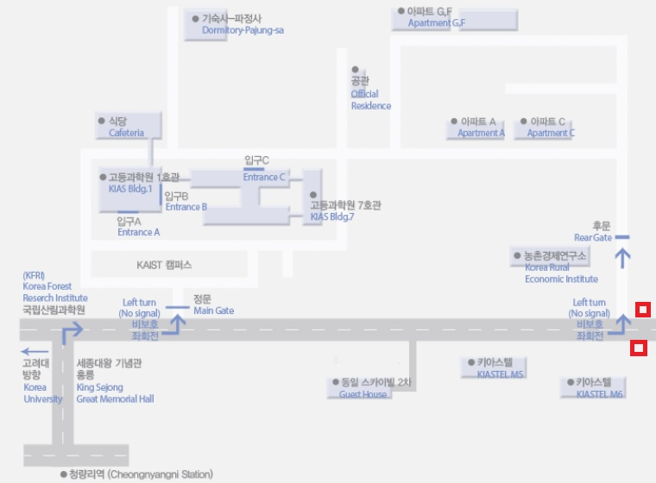

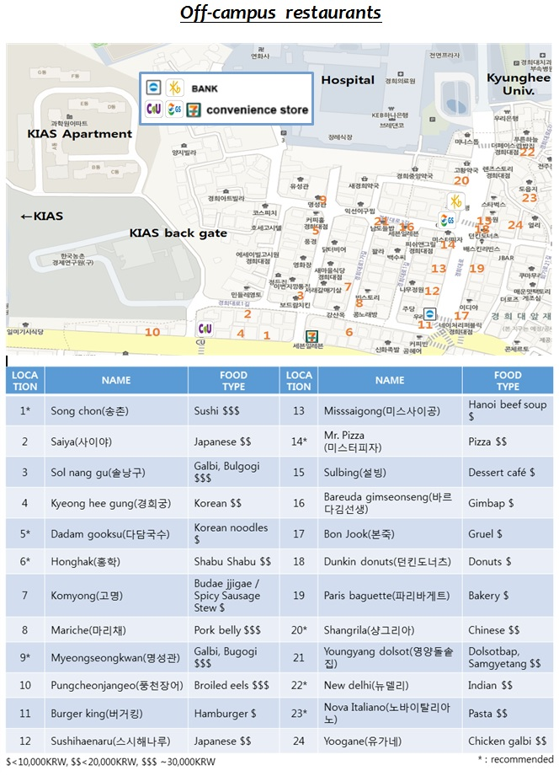

Maps and Directions

KIAS (고등과학원)
85 Hoegiro (Cheongnyangni-dong 207-43)  Dongdaemun-gu  Seoul 02455  Tel: +82-2-958-2640 | 서울시 동대문구 청량리동  207-43 고등과학원 (우:130:722)  (Show this to your taxi driver)

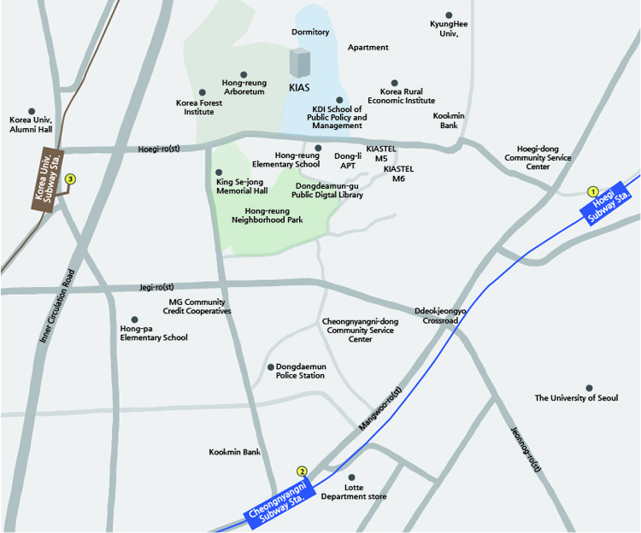

From Incheon International Airport
There are several ways to get to KIAS from Incheon International Airport. You may purchase Limousine or Premium Bus tickets or obtain information at the Transportation Information Counter located near the exits 2, 4, 9 and 13 on the passenger terminal arrival floor.
Limousine Bus
Bus No. 6002
The convenient bus to KIAS is one bound for Cheongnyangni of which number is "6002" and the bus stop at the airport is No."5B" and "12A". The fare is 10,000 Korean Won and the bus departs every 15~20 minutes. The first bus at the airport departs at 05:30 and the last bus departs at 23:30. You can get off at 'Cheongnyangni Station' bus stop, which will take about one and a half hours.
Bus No. 6101
Take a Limousine Bus No.6101 'Dobong(Seongdong)' route at the bus stop 3B, 10A (Bus fare is 14,000 won). Get off at 'Korea Univ. Station' bus stop and then take a taxi. To KIAS, it will cost less than 3,000 Korean Won.
Then, take a taxi to KIAS. To KIAS. Either from Cheongnyangni or Korea Univ. Station, it will cost you less than 3,000 Korean Won. Please show 'Direction for Taxi Driver' to a taxi driver so that he/she can understand where you are headed. For more information, please visit Incheon International Airport website.
Airport Train
Airport train is available from the airport to Seoul Station. This service will cost you 3,700 Korean Won, and total estimated time to KIAS is about an hour. You should get off at the Seoul Station, which is the last stop. Then, from Seoul Station to KIAS, you can take a subway or you can use a taxi service, which will cost you about 10,000 Korean Won.
Taxi
If you have heavy luggage, we suggest that you take a taxi. There are two different types of taxis. One is regular taxi and the other is deluxe taxi (black-colored). In case of the former, it will cost about 75,000 Korean Won from the Incheon International Airport to KIAS including a toll (7,500 Korean Won). In case of deluxe taxi, it will cost 95,000 Korean Won including toll (7,500 Korean Won). However, please keep in mind that it may cost more depending on traffic condition.
From Hoegi Station
Bus
Please go out through exit No. 1 and go straight until you arrive at an intersection. Cross the road to the right at first and then to the straight line. Cross the road and turn right. Walk straight until you see a bus stop. Take No.1215 or No.273 and get off at 'KAIST Campus/Hong-neung Elementary School' bus stop.
Taxi
Please go out through exit No.1 and take a taxi. Please show 'Direction for Taxi Driver' to a taxi driver so that he/she can understand where you are headed. It will cost about 2,400 Korean Won
From Cheongnyangni Station
Bus
Please go out through exit No. 2 and go straight, turn right at the corner and then go straight until you see a bus stop. Take No.1215 and get off at 'Hong-neung Elementary School' bus stop. Please cross the road to reach KIAS which is in the KAIST campus.
Taxi
Please go out through exit No.2 and a taxi. Please show 'Direction for Taxi Driver' to a taxi driver so that he/she can understand where you are headed. It will cost about 2,400 Korean Won.

Hope you have a safe trip

